Britaney Winston
Project Proposal
3/13
Problem Description
ShelfBuddy is a web application that helps book lovers efficiently manage their personal libraries by preventing duplicate purchases, tracking loaned books, and maintaining reading goals. Users can create a digital catalog, log borrower details with return reminders, and set personalized reading schedules with automated progress tracking.
Business Logic
ShelfBuddy allows users to set their preferred reading time, reading days, and session lengths while receiving reminders to stay on track. If a user falls behind, the app suggests catch-up sessions, goal adjustments, and alternative book recommendations based on reading habits. Users can also access reading progress reports with key stats.
User Personas and Interaction
Casual Readers can use ShelfBuddy to plan their reading, set reminders, and track progress. Scholars who frequently lend books can manage loans and avoid forgotten returns with automated tracking. Avid Readers with large collections can prevent duplicate purchases using the catalog as a quick reference while shopping.
Users can input book details such as author, and genre to keep their collection organized. The search feature allows users to find books quickly and add books to their wishlist for future purchase. The search feature will use Google Books API and will fetch book details and covers to enhance the visual appeal of the catalog. Loan tracking logs borrowers, sets due date reminders, and sends notifications for overdue books. Users can also track books borrowed from public libraries and receive return reminders.
Value and Benefits
By maintaining a digital catalog, users save money by avoiding duplicate purchases and save time by easily searching for books instead of manually browsing shelves. Although at this time books have be inputted manually, the use of the Google Books API will allow for retrieval of book information to reduce manual data entry. The loan tracking system ensures books are returned, eliminating the need to replace lost ones. Adaptive goal tracking keeps users engaged and helps build better reading habits
ShelfBuddy offers monetization opportunities through premium features like cloud storage, offline access, AI-powered recommendations, automatic sync, custom UI themes, borrower reminders, book swaps, and an ad-free experience. Partnerships with bookstores and libraries can provide discounts and event updates, enhancing user engagement.
Description of Minimum Viable Product
ShelfBuddy solves three key problems: preventing duplicate purchases, tracking loaned books, and maintaining reading goals. The user experience must be simple, clean, and mobile-friendly, ensuring quick book entry, loan tracking, and reading plan management.
Problem 1. Prevent Duplicate Purchases
Users add books to their catalog via a Book Entry Form. The system checks for duplicates and prevents redundant entries. When shopping, users can search their collection to confirm ownership.
Required Features:
- Book Entry Form
- Duplicate Detection
- Search and Filter Functionality
- Google Books API

Problem 2. Prevent Lost Loaned Books
Users log borrower details and due dates when lending books. The system marks books as “Loaned Out” and sends in-app reminders before due dates. Users can also track library loans to avoid late fees.
Required Features:
- Loan Tracking-Ability to mark books as Loaned out
- Due Date Input and Tracking
- In-App Notifications
- Public library Loan Tracker
Problem 3. Customizable Reading Plans & Progress Tracking
Users create a custom reading plan, set schedules, and receive reading reminders. Progress is logged as “In Progress” or “Completed”, with adaptive adjustments for missed sessions. Reading insights show stats on books read and total reading time.
Required Features:
- Customizable Reading Plan
- Progress Tracker
- Adaptive Adjustments
- Reading Insights & Analytics
- Reminders and Notifications
User Interface (UI) Requirements
- Simple & Mobile-Friendly – Easy book entry, loan tracking, and goal setting.
- Dashboard – Displays currently reading books, overdue loans, and new additions.
- Navigation Bar – Search field, user profile, digital catalog, loans, and reading plans.
- Notification Center – Manages reminders for loans and reading goals.

Minimal Set of Features for MVP
The frontend will use React.js for an interactive, user-friendly interface and in-app notifications. The backend will be built with Django (Python) to handle business logic, data processing, and authentication, communicating with the frontend, database, and external APIs for book details. MongoDB will store user data, book details, loan records, and reading plans, interacting with the backend for data retrieval and updates.
Architecture Components

For the frontend I will use React.js so that the interface is interactive and user friendly. React.js will be used for the in-app notifications as well. For the Backend I will use Python (Django) to handle business logic, data processing and user authentication. The Backend will communicate with the Frontend, Database, and the External API’s for book details and Firebase for notifications. For the Database layer I plan to use MongoDB to store user data, book details, loan records, and reading plans. The Database layer communicates with the Backend layer for data retrieval and updates.

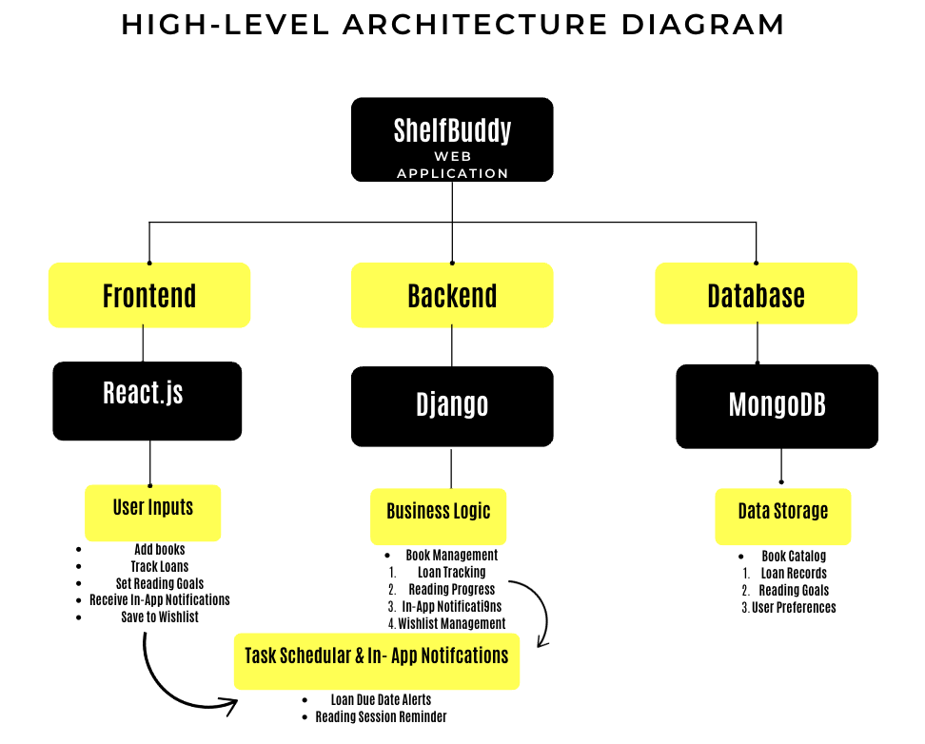

High Level Data Description
For ShelfBuddy to function efficiently, it will need to manage structured data across multiple entities in a relational database MongoDB. The data will be organized into tables/collections that store books, loans, reading plans, users, notifications, and wishlists. Below is a high-level description of the major fields and relationships in the database.
- The users table will store user Details.
  - One-to-Many (User Books, Loans, Wishlist, Reading Plans, Notifications)
- The books Table stores Books added to a user’s catalog.
  - One-to-Many (Book Loan Records)
  - One-to-One (Book Wishlist Entry)
- The loans Table stores books that have been loaned out to others.
  - One-to-Many (User Loan Records)
  - One-to-One (Loan Book)
- The reading plans table stores reading schedules and goals.
  - One-to-One (User Reading Plan).
  - One-to-One (Reading Plan Book in Progress).
- The notification Table stores system generated reminders and alerts.
  - One-to-Many (User Notifications).
- The wishlist table stores books users want to buy or read later.
  - One-to-One (Wishlist Book)

